**Statistical Inference Course Project: Part 1**

**Author: Amin Mousavi**

**Overview**

The goal of this project is to investigate and explore the exponential distribution in R and compare it with Central Limit Theorem. The exponential distribution can be simulated in R by rexp(n, λ), where λ is the rate parameter.

**Simulation Code**

We set λ=0.2 for all simulations, and will investigate the distribution of average of 40 exponentials for 1000 simulations. The code for generating the samples is as follows:

set.seed(11)

lambda <- 0.2

nosim <- 1000

n <- 40

meanSamples = matrix(rexp(nosim*n,lambda), nosim)

Means = apply(meanSamples, 1, mean)

**Sample Mean**

We set λ=0.2 for the exponential distribution. So, the theoretical mean is:

$$μ=\frac{1}{}=\frac{1}{0.2}=5$$

The average of 1000 sample means is:

> mean(Means)

[1] 4.987157

The theoretical mean and the sample mean for the given parameters are very close.

**The Variability of Sample Mean**

For λ=0.2 the theoretical variance is:

$$σ^{2}={\left(\frac{1}{}\right)}^{2}=25$$

The variance of the sample mean is:

$$\frac{σ^{2}}{n}=\frac{25}{40}=0.625$$

The variance of the sample mean from simulations is:

> var(Means)

[1] 0.6509313

These values are also pretty close.

**Distribution**

For estimating the distribution of sample mean, first we plot the histogram of sample means. Then, we plot a theoretical normal distribution and compare the plots. The code for generating the plot is:

hist(Means, breaks=50, prob = TRUE)

lines(density(Means), col="blue", lwd=2)

x <- seq(min(Means),max(Means), length=100)

lines(x,dnorm(x,mean=5, sd=sqrt(0.625)), col="red",lwd=2)

legend("topright", c("simulation","theory"), lty=c(1,1), col=c("blue","red"))

and the result is:

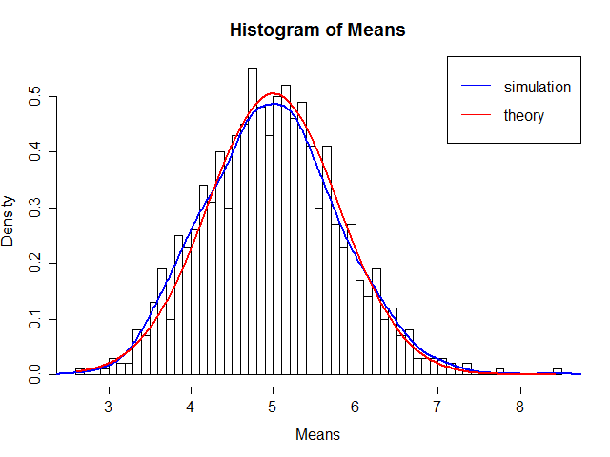

The plot clearly shows that the distribution of the sample mean is very close to the normal distribution.